Guide to Wrong Ingame Texts

Video guide can be found here:
Version 1 (older, version 2 has all of these too):
https://www.youtube.com/watch?v=__rbEgGypG8
Version 2 (updated version with all these, watch this one):
https://www.youtube.com/watch?v=strCXzeudCI

Last Updated : Y2025 - M10 - D02

What wrong texts are and how we know

Some of the descriptions in the game are wrong in their texts, as some were changed to be different and other never had the correct text to describe them correctly, many have been fixed through the ages, but some still remain, the ones below are still currently incorrect (check time of last update to see if still up to date).

The way we know these to be incorrect is by testing them ingame, for damage talents and such, if they state to be in a certain stat pool, but if we calculate them like that and they don't match up to ingame, then we know they are incorrect, by further testing we usually can figure out what they actually are.

Gear talents

  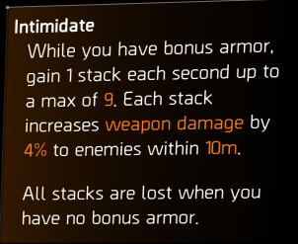 | (Perfect) Intimidate chest talent  States :  … Increases weapon damage …  Meaning stacks are weapon damage,  For normal : 9 x 1.04 = 1.36 = 36% increase  For perfect : 10 x 1.04 = 1.40 = 40% increase  Actually is :  Stacks are a self multiplicative separate multiplier.  For normal : 1.04 ^ 9 = 1.4233 = 42.33% increase  For perfect : 1.04 ^ 10 = 1.4802 = 48.02% increase  Verdict :  Wrong text.  States :  …Gain 1 stack each second…  Actually is :  Gain 3 stacks each second.  Likely unnoticed when changed from 1 stack per second that it was prior to its rebalance.  Verdict :  Wrong text.

  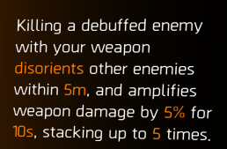 | Hunter’s Fury 4 piece talent  States :  … And Amplifies weapon damage by 5% …  Implying Stacks 5% amp additively 5 times.  1.05 x 5 = 1.25 = 25 % increase  Actually is :  Stacks are a self multiplicative separate multiplier.  1.05 ^ 5 = 1.2762 = 27.62% increase  Verdict :  Ambiguous.  Ranger has similar wording but is self additive.

  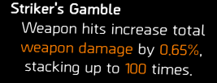 | Striker’s Battlegear 4 Piece talent  States :  … Increase total weapon damage by…  Stating that stacks are total weapon damage.  Would be additive to other sources of total weapon damage like obliterate or vigilance.  Actually is :  Stacks are self additive, separate multiplier.  Is not additive to any other pool including TWD, acting as a separate multiplier.  Verdict :  Wrong Text.

  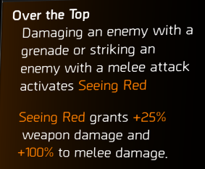 | Over the Top (Bloody Knuckles)  States :  … Grants +25% weapon damage …  Meaning that its damage increase is All Weapon Damage.  Would be additive to All weapon damage from red cores and such  Actually is :  Damage increase is Total Weapon Damage.  Additive to TWD from talents and such, much less diminished stat.  Verdict :  Wrong Text.

  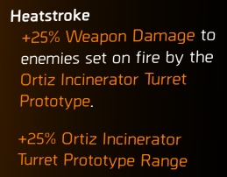 | Ortiz Exuro Backpack talent  States :  +25% weapon damage to…  Meaning that damage increase is All Weapon Damage.  Would be additive to All weapon damage from red cores and such.  Actually is :  Is a separate multiplier and is not additive to any other pool. Is affecting the striker drone as well.  Verdict :  Wrong Text.

  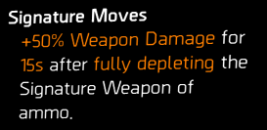 | Tip of the Spear Backpack talent  States :  +50% weapon damage for …  Damage increase is All Weapon Damage.  Would be additive to All weapon damage from red cores and such.  Actually is :  Is a separate multiplier and is not additive to any other pool.  Verdict :  Wrong Text.

  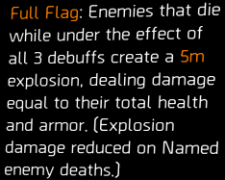 | True Patriot 4 piece talent  Full Flag Explosion  States :  … Dealing damage equal to their total health and armour …  Actually is :  Deals damage based on the player's health and armour, not the enemies.  Verdict :  Wrong Text.

  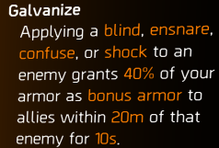  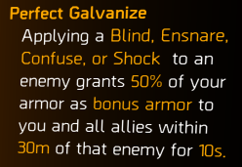 | (Perfect) Galvanise  States :  …to allies… from the normal version.  …to you and all allies… from the Perfect version.  Actually is :  Both work in the same way, applying galvanise to you and any other teammates in range.  Verdict :  Inconsistent, leading to confusion.

  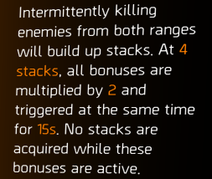 | Virtuoso 4 piece talent  States :  …All bonuses are multiplied by 2…  Actually is :  All bonuses are multiplied by 1.5.  This was correctly shown in the patch notes, but the final version has the wrong amount.  Verdict :  Wrong Text.

  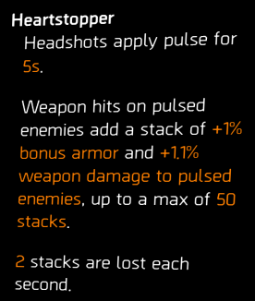 | Heartbreaker 4 piece talent  States :  … +1.1% weapon damage …  Actually is :  Not All Weapon Damage stat,  Stacks are self additive, separate multiplier.  Is not additive to any other pool including AWD, acting as a separate multiplier.  Verdict :  Ambiguous.  Should clarify that it is a separate multiplier.

Weapon Talents

  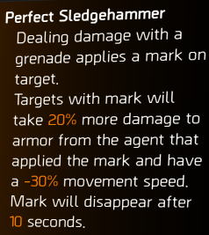 | (Perfect) Sledgehammer  States :  … more damage to armour…  Damage increase is Damage to Armour pool.  Would be additive to other DTA on build. Would not affect armour plates.  Actually is :  Damage increase is a separate multiplier to armour and armour plates. Is not additive to DTA. Does affect armour plates.  Verdict :  Wrong Text.  States :  …From the agent that applied the mark…  Actually is :  Debuff upon enemies that will increase all incoming damage to enemy, including teammates  Verdict :  Wrong Text.

  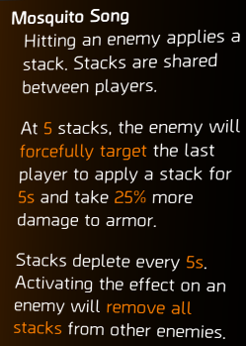 | Mosquito Song (Mosquito)  States :  ... and take 25% more damage to armour…  Meaning damage increase is Damage to Armour pool.  Would be additive to other DTA on build. Would not affect armour plates  Actually is :  Damage increase is a separate multiplier to armour and armour plates. Is not additive to DTA. Does affect armour plates.  Verdict :  Wrong Text.

  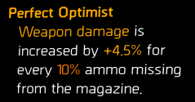 | (Perfect) Optimist  States :  … For every 10% ammo missing …  Implying it is in 10 discreet increases.  Actually is :  Every shot does more damage than the last, it is not in segments, it is 35% (45%) divided by mag size as the increase per shot fired.  Verdict :  Wrong Text.

  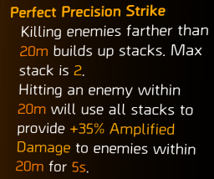 | (Perfect) Precision Strike  States :  …Will use all stacks to provide 25% (35%) amplified damage to …  Actually is :  Description is making it sound like you need both stacks and together they give 20% (35%), but each stack gives its own increase, and you can trigger with just one stack.  Verdict :  Misleading, the text should be reworked to say “will use all stacks, each stack provides”.

  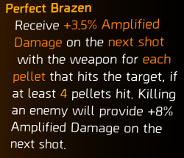 | Perfect Brazen  States :  … killing an enemy will provide +8% amplified damage on the next shot.  Actually is :  There is no bonus for a kill shot, a kill shot will trigger a full stack of brazen, for both normal and perfect versions.  Likely left over from when brazen was 8%, and likely only perfect was meant to have a kill trigger a full stack.  Verdict :  Wrong Text.

  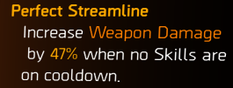 | (Perfect) Streamline  States :  …when no Skills are on cooldown.  Actually is :  When no skills are in use or on cooldown.  As any skill being used or deployed also disables the talent. In the patch notes of the season it was also explained as working this way, but the ingame text never got changed.  Verdict :  Wrong Text.

  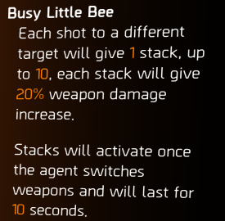 | Busy Little Bee  States :  … will give 20% weapon damage increase  Actually is :  Is a self additive separate multiplier and is not additive to any other pool. It is not All Weapon Damage as it suggests.  Verdict :  Wrong Text.

Misc.

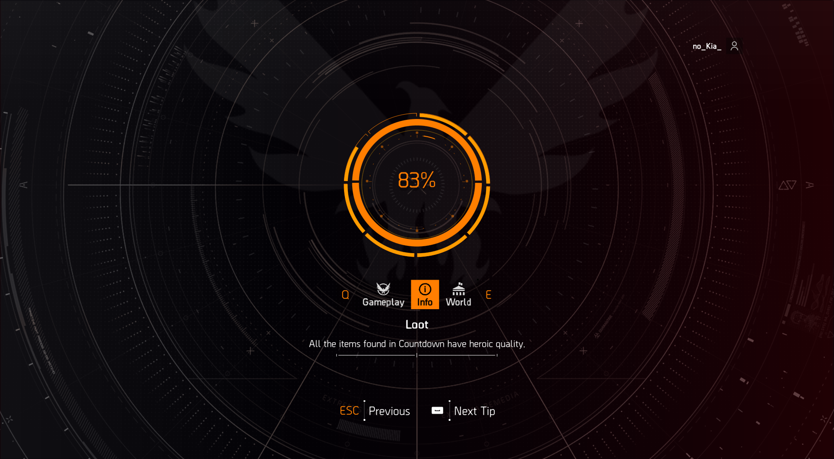
Countdown Loot Loading Screen Tip

States :
All the items found in Countdown have heroic quality.

Actually is :
Each countdown difficulty tier has corresponding quality of loot.
For instance consider normal and hard difficulty countdowns dropping purples.

Verdict :
Wrong text, outdated due to addition of difficulty selection to countdown.

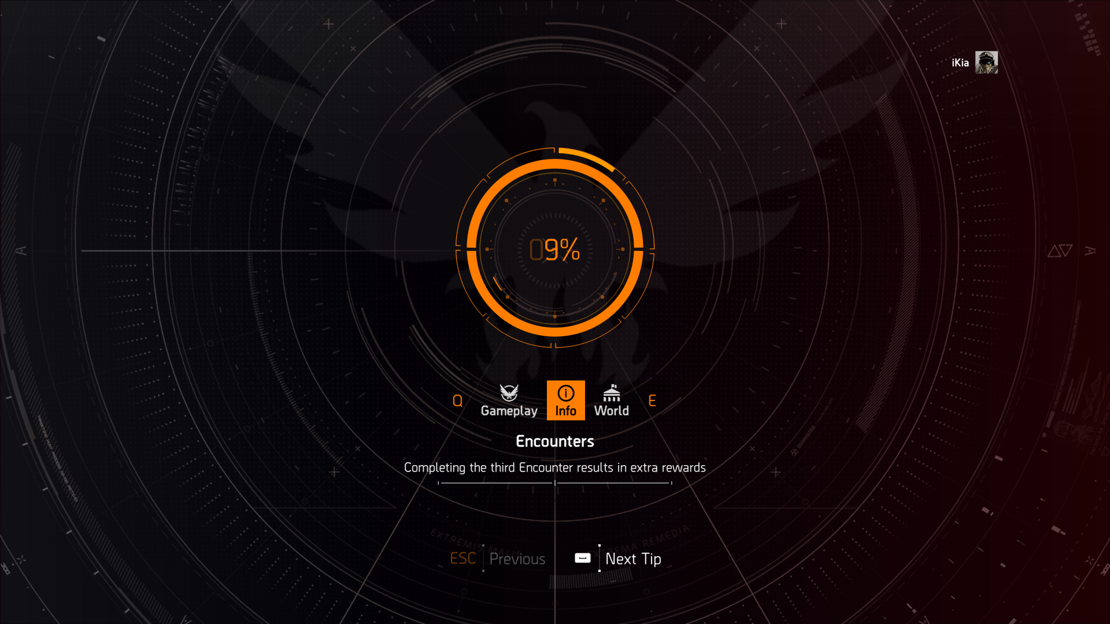
Countdown Encounters Loading Screen Tip

States :
Completing the third encounter results in extra rewards.

Actually is :
While there are extra rewards, that will be one (1) extra countdown requisition that will get doubled to two (2) for extracting.

Verdict :
Misleading, there are rewards, but not of commensurate value.


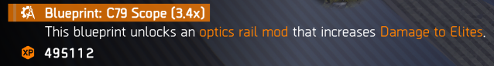


Missing Scavengers and Greenhouse Community Side Mission Rewards

States :
... that increases Damage to Elites
Rewards an weapon mod with damage to elites.

Actually is :
Weapon mod that increases CHC for C79, and Headshot for Muzzle Brake .45.
Damage to elites no longer exists as a stat in the game.

Verdict :
Outdated, was never updated after gear 2.0.


Health Damage third stat for weapons

States :
9.5% DTH.

Actually is :
10% DTH, testable with the stat screen showing 10, also calculations will only match 10%.

Verdict :
Wrong Text.

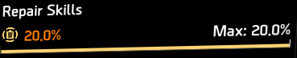



Inconsistent use of Skill Repair and Repair Skills

States :
Both Repair Skills and Skill Repair for the same stat, entirety of descent uses Skill Repair as the stat

Actually is :
All of them should be Repair Skills, including Descent.
Skill Repair should only be used for Artificer Hives stat.

Verdict :
Inconsistent, leading to confusion.

Links to my other guides, the Build Collection, DMG/DPS Calculators and many other things:

https://docs.google.com/document/d/15mg-_sjowh5_8bUp2VIBqnDxCDqz-xJOISl0DlG3RDU

TODO :
SysCor amp not TWD
Scorpio debuff on 8 instead of 9?
Vanguard raid version

